

Comsats University Islamabad, Attock Campus

Information Security

Lab Assignment 02

Submitted to

Ms. Ambreen Gul

By

Student Name | Registration No
Muhammad Yousaf Qazi | FA23-BSE-030

(1)
Stream Cipher (Salsa20-inspired)
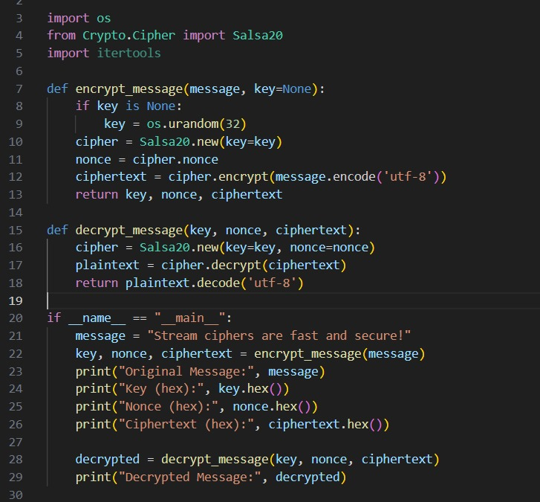

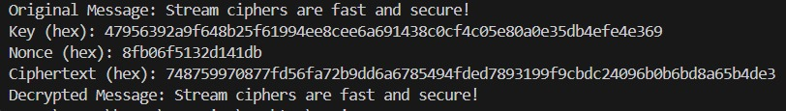
Output

Salsa20 is a modern stream cipher known for speed and security.
It generates a keystream using the key and nonce combination and XORs it with plaintext.
We use crypto.cipher.salsa20 from pyCryptodome library.

(2)
Adversarial Attack (Brute Force Simulation)
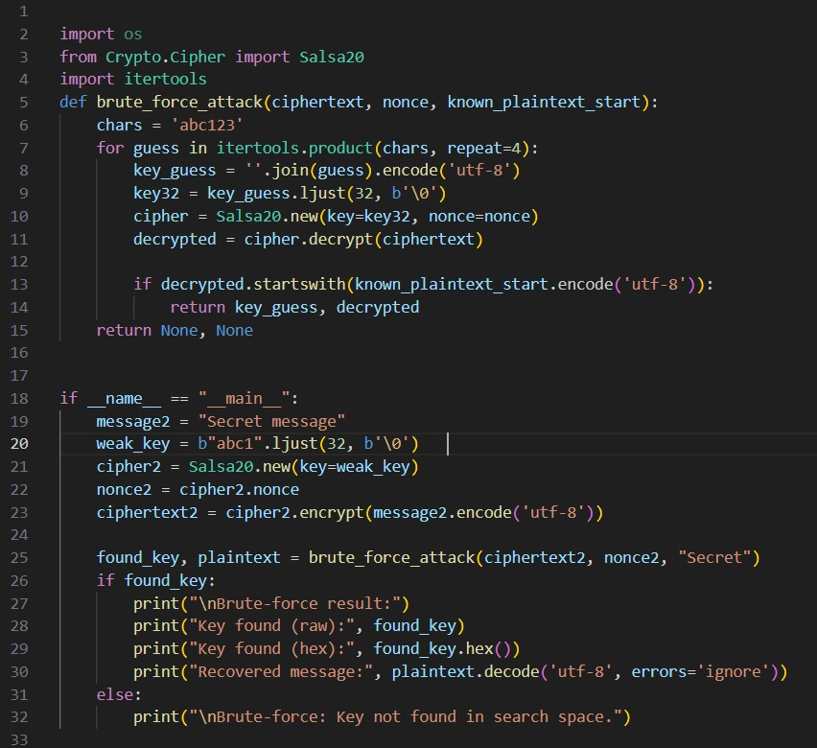

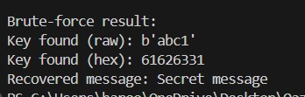
Output

This attack demonstrates key weakness if the key is short or predictable, attackers can guess it.
We limit the search space (‘abc123’) to show how brute force can work on weak keys.
Real slasa20 uses 256 bits keys making brute force impossible in practice.

Explanation:

To design and test a stream cipher using salsa20 and evolutes its resistance to brute-force attacks.

1.Immplemented encryption/decryption using salsa20(PyCryptodome).

2.Tested encryption with random 256-bits key.

3.Simulated a brute-force attack with a weak 4-character key.

4.Observed that short keys can be guessed; long keys remain secure.

Conclusion:
Salsa20 provides high speed, secure encryption when using a strong random 256-bit key. However weak or reused keys expose vulnerability to brute-force and known plaintext attacks.

